

**Software Requirements Specification**

**Product – Online shop website**

# Introduction

## Purpose

This document provides an overview of an Online shopping website from a functional perspective, highlights some technical considerations relating to the application, and also highlights some technical and organizational implementation issues.

## Scope

The scope of this project is description of existing Online shopping website [www.most.bg](http://www.most.bg/). “Team Kilgharrah” will describe [www.most.bg](http://www.most.bg/) , its registration and login process, sale and compare functionalities, forum and news sections.

It provides an effective approach to represent business of selling products and communication with existing and new customers.

## Overview

The rest of this document contains the overall description of the Online shopping website and the specific requirements for the system.

# Overall Description

## Product Perspective

M[ost.bg](http://www.most.bg/) is an existing website. Customers / Buyers are the end users of system. Access is via internet, using any conventional web browser. The user interface is intuitive and logical and requires no training. The online shop is running on dedicated webserver available 24/7 hosted by the software provider.

## Product functions

### Offers monitor and control of user registration:

Website m[ost.bg](http://www.most.bg/) is brand representative and selling website for MOST Computers company. Registration is one of basic functionalities allowing site administrator to monitor and control registration of users. The effectiveness of website monitor and control of user registration functionality supports other site functionalities. For example, unregister user cannot use other functionalities, like shopping and monitoring specific products. This feature allows MOST Computers company: to give and revoke access for users, depending on their behavior; to monitor user activity and purchasing habits; to see what interests user and what content to show him.

### Offers registration functionalities for end users

Registration functionality also allows customers to register as users in website. Registering to website provides to user more functionality to site, besides read-only. Registering as website users allows customers to have own user account with information regarding their personal data, orders, payments and deliveries, favorite products, etc.

### Shopping functionalities:

Shopping function is one of main function of website. Online cart module provide functionalities to add, remove and edit items in cart, payment options and delivery tracking.

### Forum Functionalities:

As register user, each customer have the option to post questions in forum and answer to other user questions.

### Search and Filter Functionalities:

Search and Filter Functionalities help customer to find product he is looking for easier. Search is very useful functionality, as shop has great amount of products. User has possibility to filter products by categories.

## Constraints

**The following are the constraints:**

* The documentation and testing project must be completed within the budget
* The documentation and testing project must be completed within a specified period of time.
* The website should be up 24/7.
* The website should enforce user authentication security and guarantee reliability.

## Assumptions and dependencies

Direct customers/companies already having prior IT knowledge will be targeted, as they are more often to search for high quality computer systems from upper price range. This would lead to the faster growth of sales as they can create great revenue.

# Flow Chart

* **Get the latest news for the website**
* **Latest Hardware news**
* **Articles for new products**

**Customer**

**Browse Features**

* **Hp Products**
* **Components**
* **Laptops**
* **Personal Computers**
* **Servers**
* **Printers**
* **Consumables**
* **Accessoaries**
* **Smartphones**

**News**

**Browse Products**

**Navigation**

* **Auto Suggestions**
* **Filters**
* **Categories**
* **Subcategories**

**Search For Products**

**Compare products**

**Compare Products**

* **Add similar products for comparison**
* **Detailed Side By Side Description**

**Settings**

* **Edit User Settings**
* **Manage Favorites**
* **Orders**
* **Bulletin Subscription**
* **Software Download**

**Login**

**Add to Favorites**

**Add to Cart**

**Purchase Product**

**Forums**

* **Ask questions**
* **Get help from other users and staff**

# Specific Requirements

## Product Functions

|  |  |  |  |
| --- | --- | --- | --- |
| **Class Of Use Cases** | **№** | **Use Cases** | **Description Of Use Cases** |
|
| Related To System Authentication | 1 | Registration. | User can register to be able to buy products. |
| 2 | Login. | Login to the pc hardware store. |
| 3 | Change Password. | User can change Password |
| Related to User Settings | 4 | Edit First & Last name. | User can edit First and Last names. |
| 5 | Change Email Address. | User can edit email address. |
| 6 | Set Up Delivery Address. | User can add delivery address. |
| 7 | Add new Delivery Address. | User can add additional delivery addresses and choose between them. |
| 8 | Orders. | User can see his orders and history in the Orders section of the profile page |
| 9 | Wish List Page. | User can add products to wish list. Wish list is viewable in the Profile Page |
| 10 | Product Comments. | User can leave comments/reviews for products. |
| 11 | Software Download. | The user can Purchase software and is able to download the software through a specific section in the Profile page. |
| Related To Search. | 12 | Search Products. | Users should be able to search products by name. |
| 13 | Search Suggestions. | Suggestions are offered based on entered keyword. |
| 14 | Search Filter. | Based on the search result, users can filter the output. |
| 15 | Search Categories. | Displayed search result based on a user selected category. |
| Related To Navigation. | 16 | Categories. | Display categories of products. |
| 17 | Subcategories. | Every category has unique subcategories. |
| 18 | Filters. | Every subcategory has a unique set of filters. |
| Related To Product Comparison | 19 | Add Products to Compare. | Add product to compare list. |
| 20 | Compare Products. | Detailed Product Specification is displayed in a new window. |
| Related To Forum. | 21 | Ask a question. | User can create a topic to ask questions. |
| 22 | Display Questions. | Displays questions from different users. |
| 23 | Filter questions. | Filters question results. |
| Related To Product Purchase. | 24 | Change Currency | Currency can be changed. |
| 25 | Add Product To Cart. | Product is added to the cart. |
| 26 | Increase Quantity. | Product quantity is increased total price is adjusted. |
| 27 | Decrease Product Quantity. | Product quantity is decreased, total price is adjusted. |
| 28 | Remove Product From Cart. | The product is removed from the cart. |
| 29 | Purchase Product. | User can choose to finalize the purchase and buy the product. |

## Functional Requirements

We describe the functional requirements by giving various use cases.

*Main Pre Condition: Installed browser and active internet connection.*

***Use Cases Related To System Authentication.***

**Use Case 1: Registration.**

1. Load the website.
2. Click “Register” button.
3. Input Information in mandatory fields.
4. Click Countinue button.
5. User Is Registered and can log into the website.

**Use Case 2: Login.**

1. Load the website.
2. Click Log in button.
3. Enter Valid credentials.
4. User is logged in to the website.

**Use Case 3: Change Password**

1. Load the website.
2. Click Log in button.
3. Enter Valid credentials.
4. User is logged in to the website.
5. Navigate to user profile, Details.
6. Input Current password.
7. Input new password.
8. User Password is changed.

**Use Case 4: Change Password**

1. Load the website.
2. Click Log in button.
3. Enter Valid credentials.
4. User is logged in to the website.
5. Navigate to user profile, Details.
6. Input New First and Last name.
7. Click Save button.
8. User First and last names are changed.

***Use Cases Related to User Settings.***

**Use Case 5: Change Email.**

1. Load the website.
2. Click Log in button.
3. Enter Valid credentials.
4. User is logged in to the website.
5. Navigate to user profile, Details.
6. Input New email address.
7. Click Save button.
8. User email address is changed.

**Use Case 6: Add delivery address.**

1. Load the website.
2. Click Log in button.
3. Enter Valid credentials.
4. User is logged in to the website.
5. Navigate to user profile, Payment and Delivery.
6. Clack add new address button.
7. User is redirected to an address form.
8. Fill in mandatory fields and click save button.
9. User added new delivery address.

**Use Case 7: Orders.**

1. Load the website.
2. Click Log in button.
3. Enter Valid credentials.
4. User is logged in to the website.
5. Navigate to user profile, Orders.
6. If user has made orders they will be described in this section of the profile.
7. If user does not have any orders, a friendly message will inform that.

**Use Case 8: Wish list.**

1. Load the website.
2. Click Log in button.
3. Enter Valid credentials.
4. User is logged in to the website.
5. Navigate to different products.
6. Click on add to wish list button on desired products.
7. Products are added to the user’s wish list.
8. User can view the selected products in the wish list section of the profile page.

**Use Case 9: Product Comments.**

1. Load the website.
2. Click Log in button.
3. Enter Valid credentials.
4. User is logged in to the website.
5. Navigate to a product.
6. Click on Comments tab and Leave a comment.
7. User left a comment for the product.
8. User can view the comment they made in the comments section of the profile page.

**Use Case 10: Software download.**

1. Load the website.
2. Click Log in button.
3. Enter Valid credentials.
4. User is logged in to the website.
5. Navigate to a software product and buy it.
6. The software product that the user bought is available for download in the Software download section of the profile page.

**Use Case 11: Search.**

1. Load the website.
2. Navigate to the search field.
3. Type a keyword and press enter.
4. User is presented with search results based on the input keyword.

***Use Cases Related Search.***

**Use Case 12: Search Suggestions.**

1. Load the website.
2. Navigate to the search field.
3. Start Typing a keyword.
4. User is presented with search suggestions based on current input.

**Use Case 13: Search Suggestions.**

1. Load the website.
2. Navigate to the search field.
3. Type a keyword and press enter.
4. User is presented with search results based on the input keyword.
5. User can further filter the search outcome by using a provided filter.

**Use Case 14: Search Categories.**

1. Load the website.
2. Navigate to the search field.
3. Type a keyword and press enter.
4. User is presented with search results based on the input keyword.
5. User can further narrow the search outcome by using provided categories.

**Use Case 15: Search Categories.**

1. Load the website.
2. Navigate to the search field.
3. Type a keyword and press enter.
4. User is presented with search results based on the input keyword.
5. User can further narrow the search outcome by using provided categories.

***Use Cases Related To Navigation.***

**Use Case 16: Categories.**

1. Load the website.
2. Navigate to Categories tab.
3. Instead of using the search functionality the user can choose to browse through a set of categories.

**Use Case 17: Subcategories.**

1. Load the website.
2. Navigate to Categories tab.
3. Click on a category.
4. User is provided with a unique set of subcategories depending on the chosen main category.

**Use Case 18: Filters.**

1. Load the website.
2. Navigate to Categories tab.
3. Click on a category.
4. Choose a subcategory.
5. The user can further narrow the search by using a set of additional filters.

***Use Cases Related Product Comparison.***

**Use Case 19: Add Products to Compare.**

1. Load the website.
2. Navigate to products.
3. Click compare button
4. Products are added to a comparison list.

**Use Case 20: Compare Products.**

1. Load the website.
2. Navigate to desired products.
3. Click compare button
4. Products are added to a comparison list.
5. Click compare button.
6. User is redirected to the comparison page where detailed information about the chosen products is presented.

***Use Cases Related to Forum.***

**Use Case 21: Ask a question.**

1. Load the website.
2. Navigate to Forum section of the website.
3. User can create a topic to ask specific questions and get answers from other user or the staff.

**Use Case 22: Display Questions.**

1. Load the website.
2. Navigate to Forum section of the website.
3. User can view and filter through other users’ questions and give answers or vote for the topics.

**Use Case 23: Filter Questions.**

1. Load the website.
2. Navigate to Forum section of the website.
3. User can apply filters to look for specific questions.

***Use Cases Related Product Purchase.***

**Use Case 24: Change Currency.**

1. Load the website.
2. Navigate to the currency menu.
3. User can switch between BGN and EUR currencies.

**Use Case 25: Add Product To Cart.**

1. Load the website.
2. User navigates to products.
3. User can click the buy button.
4. Products are added to cart.

**Use Case 26: Increase Quantity.**

1. Load the website.
2. User navigates to products.
3. User can click the buy button.
4. Products are added to cart.
5. User can increase the quantity of the products for purchase.

**Use Case 27: Decrease Product Quantity.**

1. Load the website.
2. User navigates to products.
3. User can click the buy button.
4. Products are added to cart.
5. User can decrease the quantity of the products for purchase.

**Use Case 28: Remove Product From Cart.**

1. Load the website.
2. User navigates to products.
3. User can click the buy button.
4. Products are added to cart.
5. User can remove products from cart by clicking remove product button.

**Use Case 29: Purchase Product.**

1. Load the website.
2. User navigates to products.
3. User can click the buy button.
4. Products are added to cart.
5. User can click button to finalize the purchase.

## User Screens

1. Register Page

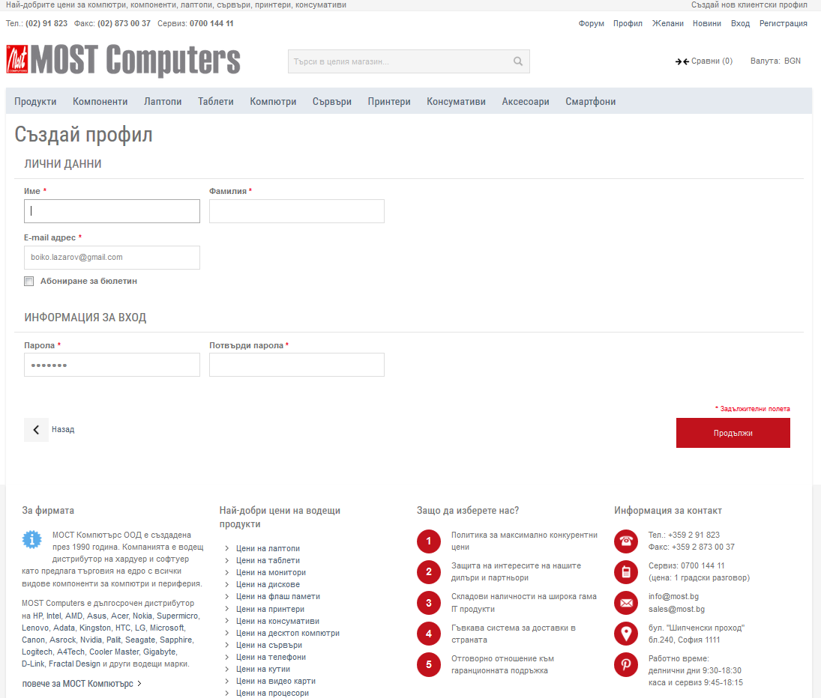

1. Log In

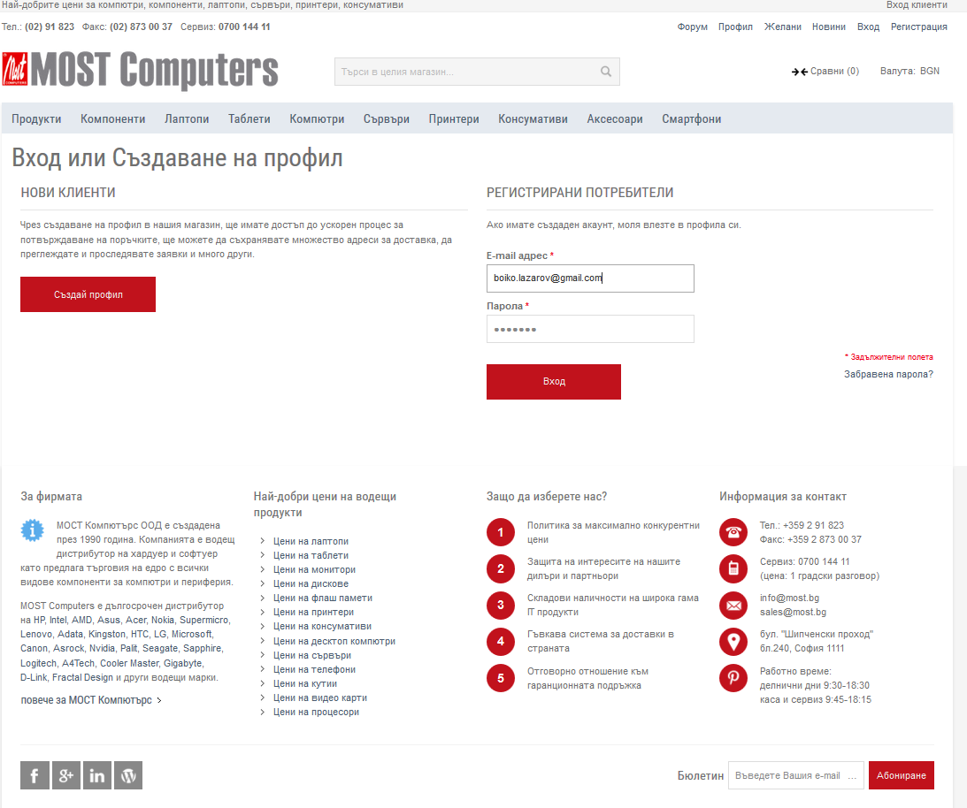

1. Profile Page

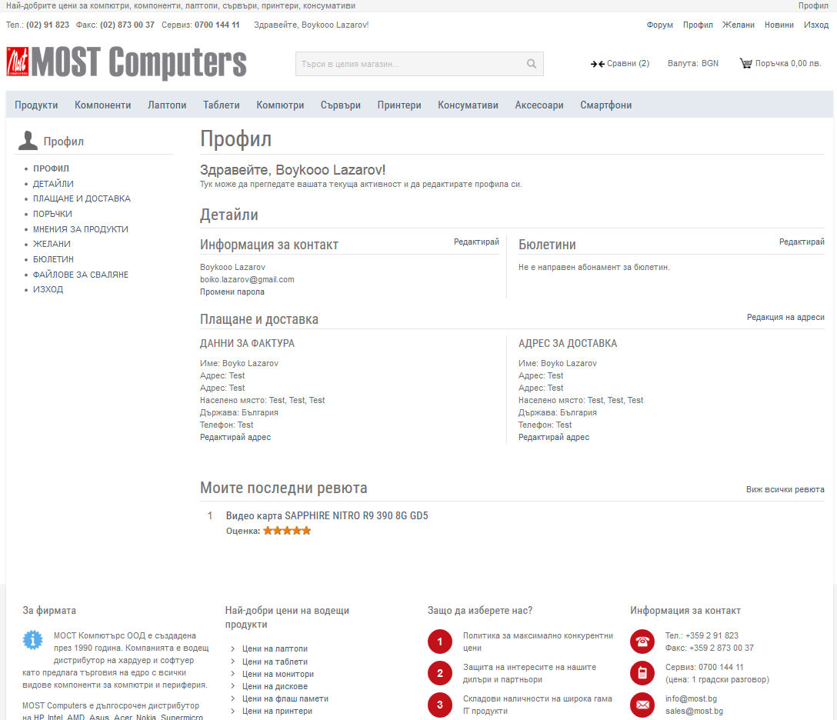

1. Home Screen

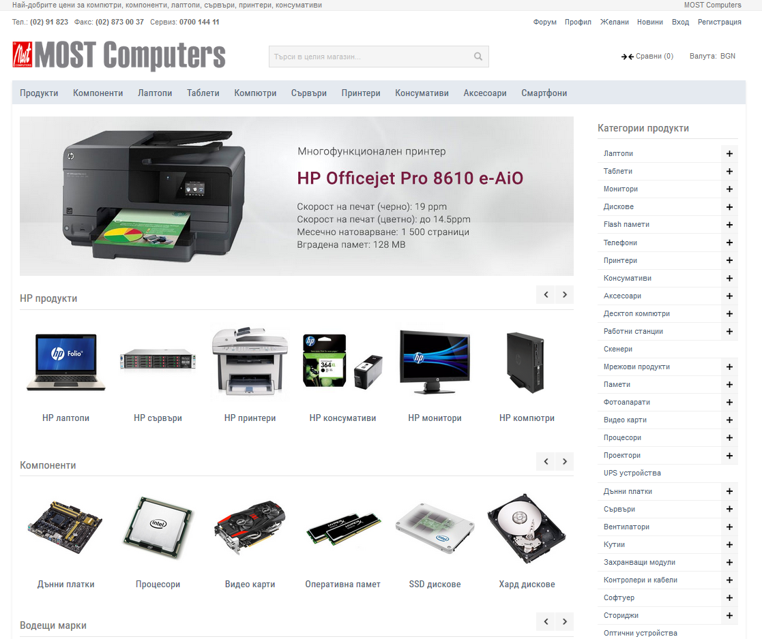

1. Product Categories and subcategories

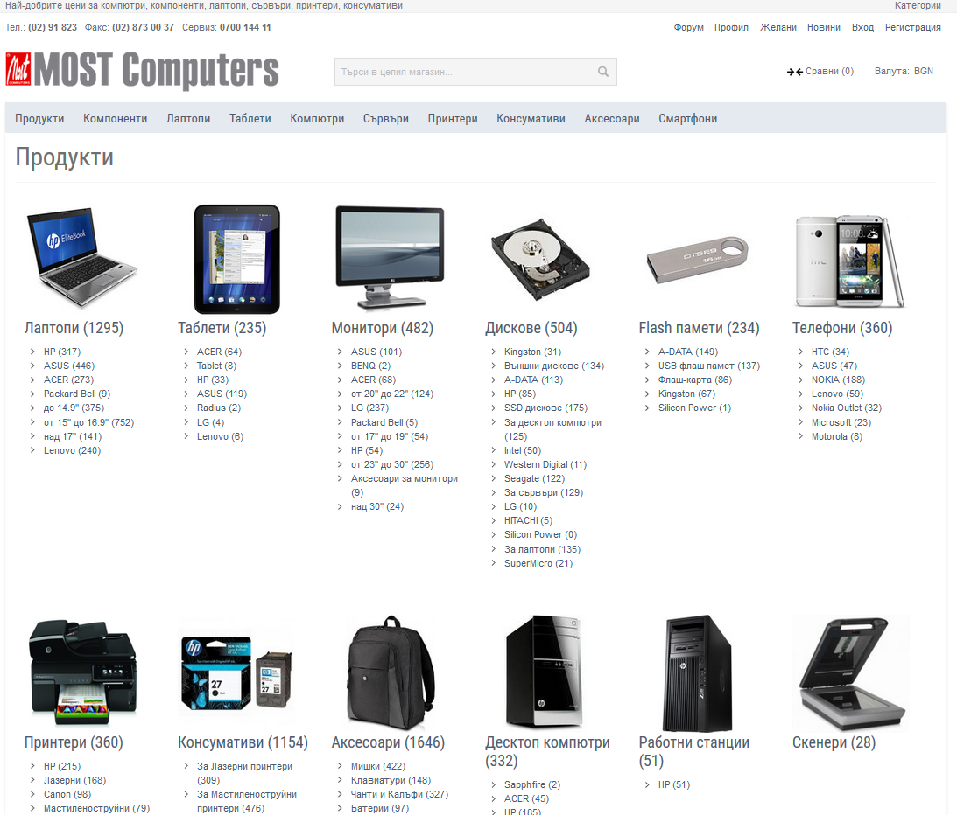

1. Filters

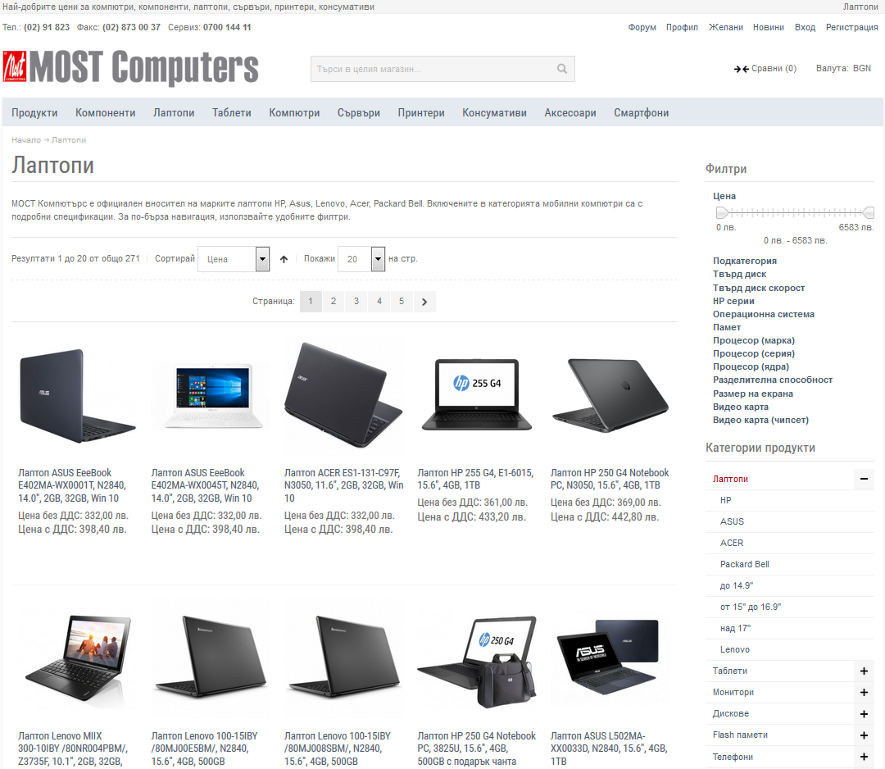

1. Compare Menu

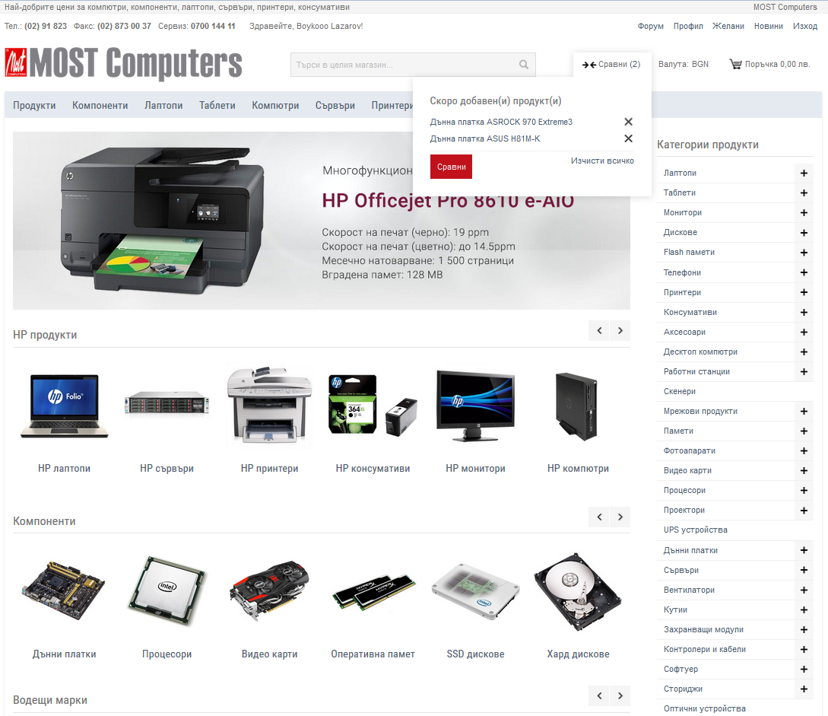

1. Compare Products

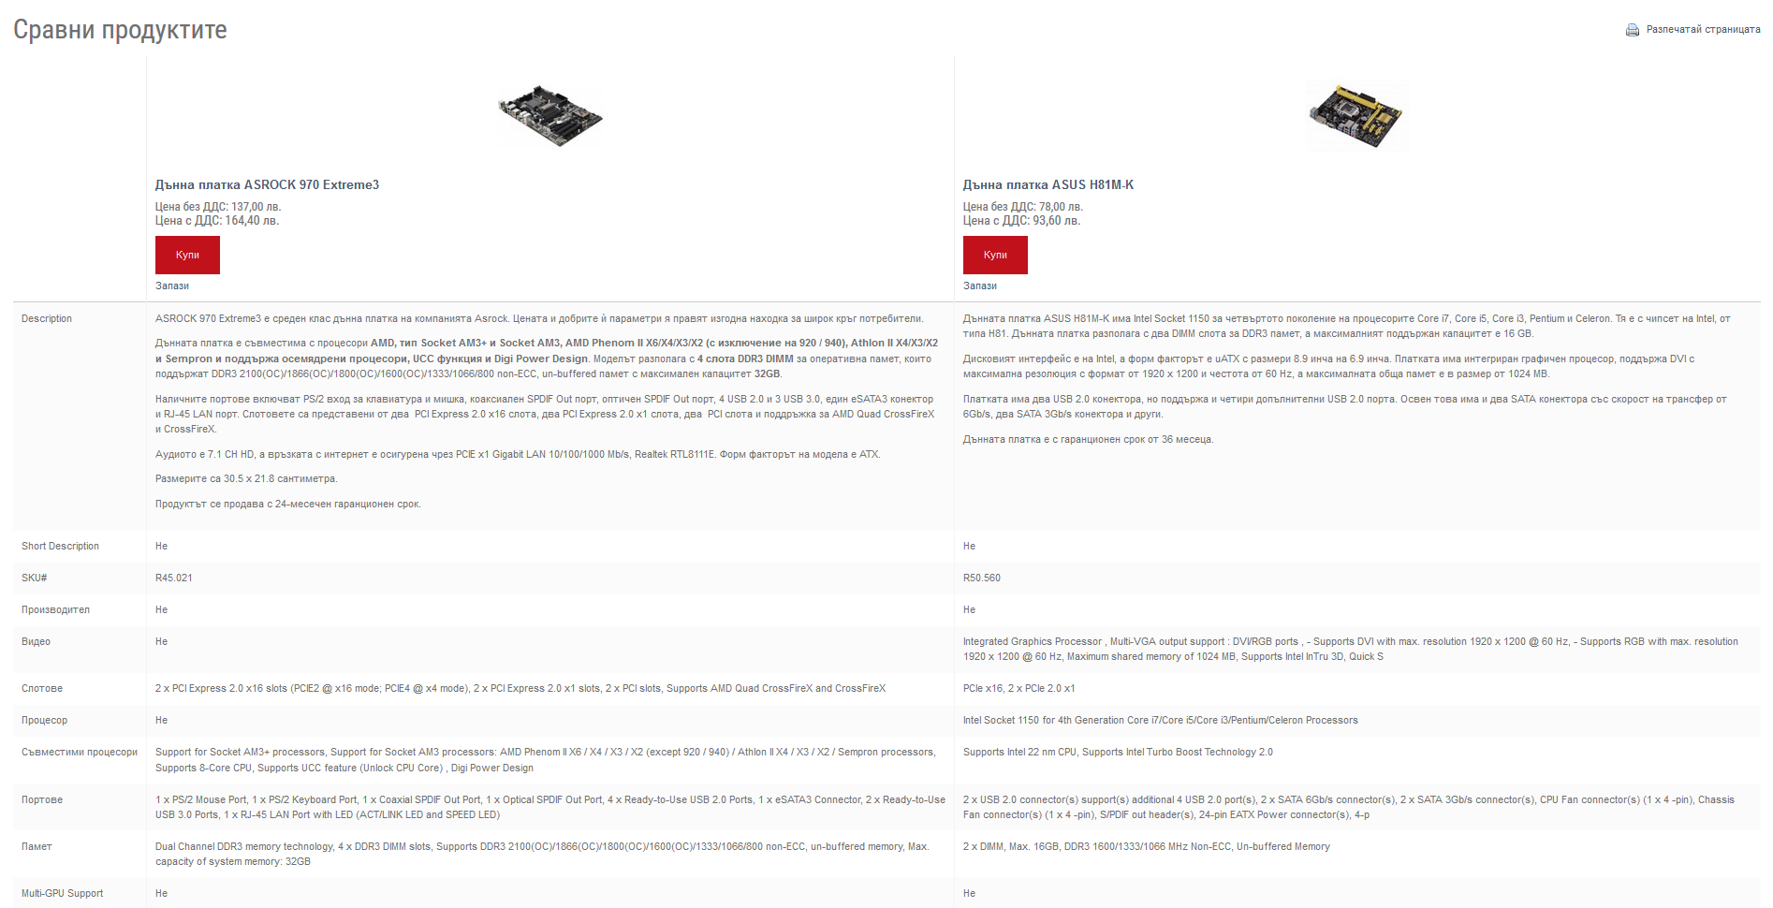

1. Forum

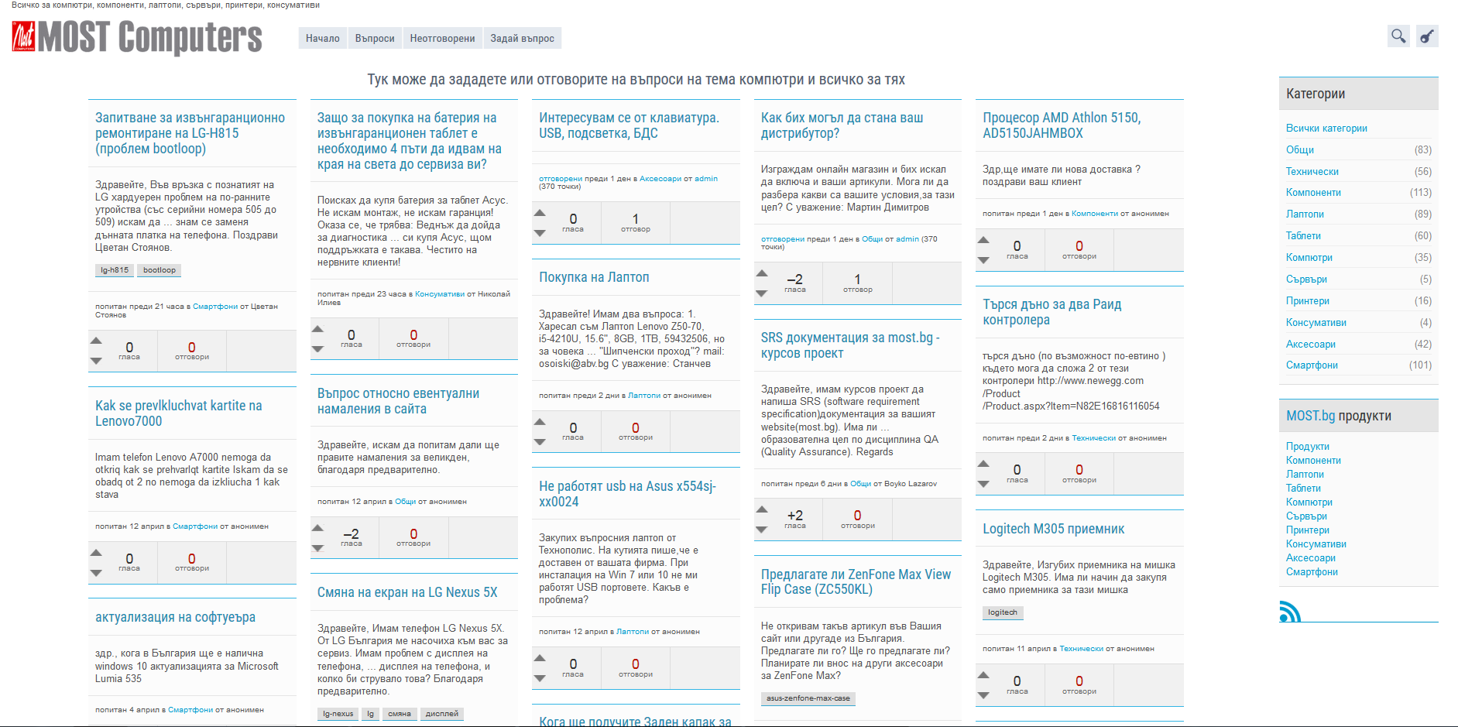

1. Wish List

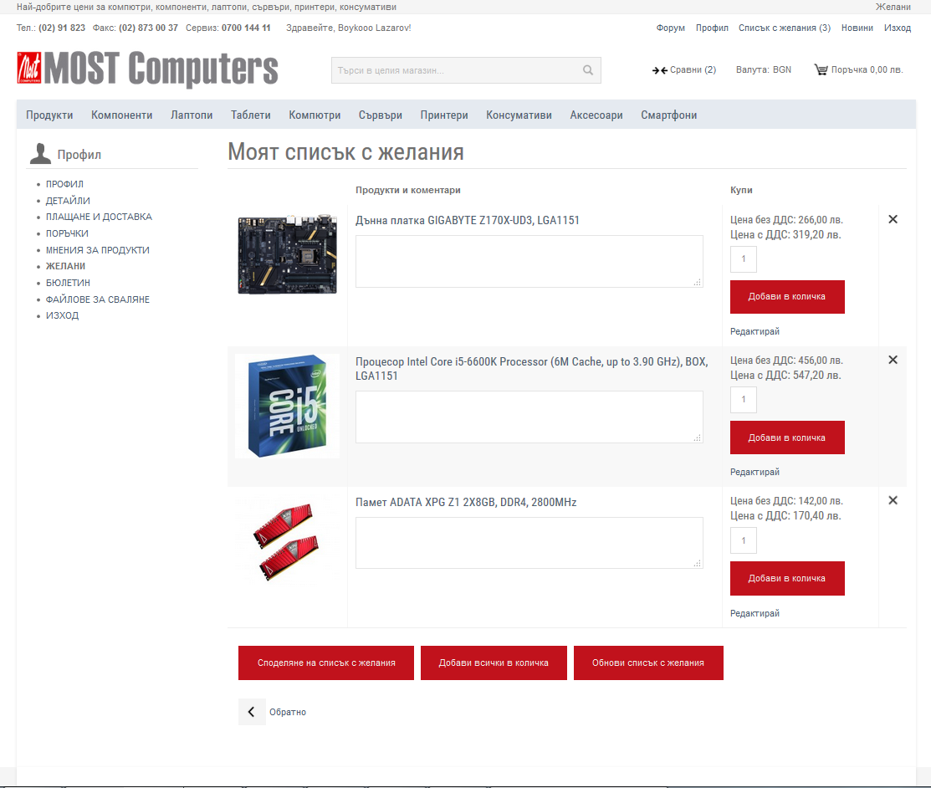

1. Cart

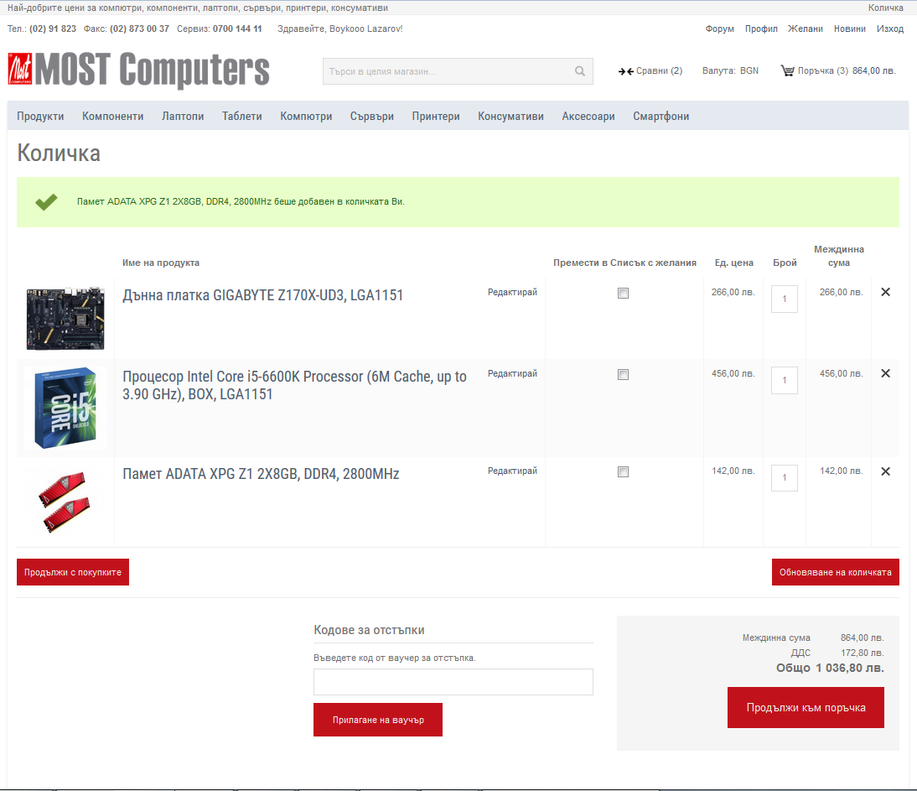

## Reliability

Reliability is an important factor to make Most.bg trustable. Some issues should be considered as following:

### Availability:

Most.bg should be available 24 hours per day, 7 days per week. Maintenance should be done without web shop stop working and soon as possible.

### Mean Time Between Failures (MTBF):

3 month.

### Mean Time to Repair (MTTR):

2 hours

### Maximum Bugs or Defect Rate:

Less than 1 minor bug per 1000 lines of code.

### Bugs or Defect Rate:

No critical bug that causes data loss or system crash is allowed.

## Performance

### The information retrieval should be as fast as possible for customer satisfaction.

To ensure this, the consumer should be able to load web application in 5 seconds. The pages loading should not take a long time to be processed and all functionality must work properly.

### The site should be able to serve 25 percent of all customers at the same time.

The site should be able to serve 25 percent of all customers simultaneously, which may be about several thousand for a large scaled online shop.

### Separation of connection handling and data processing

Separation of connection handling and data processing would definitely improve the overall system performance as well as cost incurred.

### Application runs on an online platform

Slow data retrieval because of poor programming must be absolutely discarded since the application runs on an online platform.

### Minimize the data transfer time

The size of data sent to the user can be limited to an upper bound, especially for flyers and all kind of ads, to minimize the data transfer time.

### Size of the secondary storage

The larger the primary memory, the faster the applications would run. Moreover the size of the secondary storage should be sufficient for data swapping, recovery and backup procedures.

## Supportability

### Compatible with Browsers

* Microsoft Internet Explorer 9+
* Mozilla Firefox
* Google Chrome
* Opera
* Safari

## User support and help

### User forum

Users can use forum to find any kind of information and frequently asked questions. Also they can ask questions and reply too.